Вопросы по страноведению для 7-11 классов
QUIZ: Are you an expert on Great Britain?
1. What is the capital of Great Britain?
a) Edinburgh b) Boston c) London
2. How many parts does Great Britain contain?
a) 4 b) 3 c) 5
3. What is the English flag called?
a) Union Patric b) Union Jack c) Lines and Crosses
4. Who is the symbol of the typical Englishman?
a) John Bull b) John Bell c) St.Patrick
5. What is the London underground called?
a) The tube b) the metro c) the subway
6. Who us the Head of State in Britain?
a) The Mayor b) the Queen c) the Prime Minister
7. What is the river in London?
a) Thames b) London c) Avon
8. What is the most expensive part of London?
a) West End b) East End c) Westminster d) the city
9. What colour are the taxis in London?
a) blue b) red c) black
10. The building in the picture is…
a) St. Paul’s Cathedr b) The British Museum c) The National Gallery
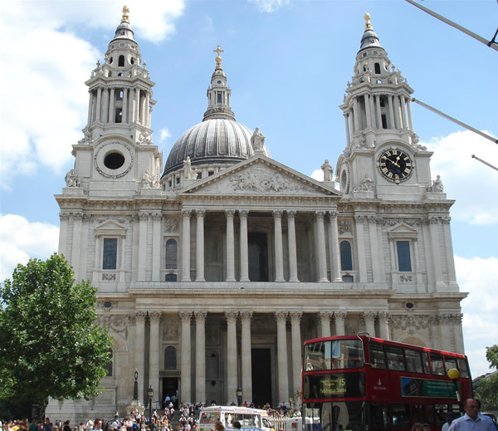

11. If you go to London, you’ll see…
a) the White House b) St. Paul’s Cathedral c) Greenwich
12. English people say…
a) Candies b) cookies c) sweets
13. What is the home of the Queen?
a) Buckingham Palace b) the White House c) Westminster Abbey
14. What city did The Beatles come from?
a) London b) Manchester c) Liverpool
15. They say the Loch Ness Monster Lives in a lake in…
a) Scotland b) Wales c) Ireland

Вопросы по страноведению для 7-11 классов
QUIZ: Are you an expert on the USA?
1. What is the capital of the USA?
a) Ottawa b) Washington, D.C. c) New York
2. How many states are there in the USA?
a) 52 b) 50 c) 51
3. What is the American flag called?
a) Union John b) Union Jack c) Stars and stripes
4. The cartoon symbol of the American government is…
a) Uncle Ben b) Uncle Mike c) Uncle Sam
5. What is the New York underground called?
a) the metro b) the tube c) the subway
6. When did Christopher Columbus discover America?
a) in 1492 b) in 1592 c) in 1392
7. How often do American people choose a new President?
a) every 5 years b) every 4 years c) every 3 years
8. What is the most expensive part of New York?
a) Long Island b) Manhattan c) Staten Island
9. What colour are the taxis in New York?
a) black b) yellow c) green
10. The building in the picture is …
a) The Capitol b) The Pentagon c) The White House
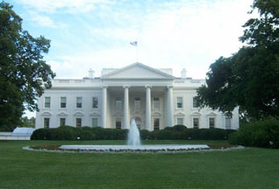

11. If you go to New York, you’ll see…
a) Big Ben b) The Capitol c) The Empire State Building
12. American people say…
a) biscuits b) cookies c) sweets
13. What is the home of the President?
a) The Capitol b) The White House c) The House of Representatives
14. What do call New York?
a) Small pot b) big apple c) melting pot
15. What do American people call their police officers?
a) Copper b) cops c) bobbies

